EXPERIMENT 15
Demonstrate how to work with Git branches and resolve merge conflicts when collaborating with others.
Tasks:
1. Clone a shared repository to your local machine.
2. Create a new branch and switch to it.
3. Make changes to a file (e.g., update a README or modify
code in a specific function).
4. Commit your changes.
5. Push the changes to the remote repository.
6. Before merging, pull the latest changes from the main branch.
7. Switch back to your feature branch.
8. Merge the main branch into your feature branch.
9. If there are conflicts, resolve them manually by editing the
conflicting files. After resolving conflicts, mark the conflicts
as resolved.
10. Commit the resolved merge.
11. Push your feature branch with the merged changes to GitHub
and create a pull request.
12. Submit a summary of the steps you performed, the conflicts
you encountered, and how you resolved them.

Step 1: Clone the Repository
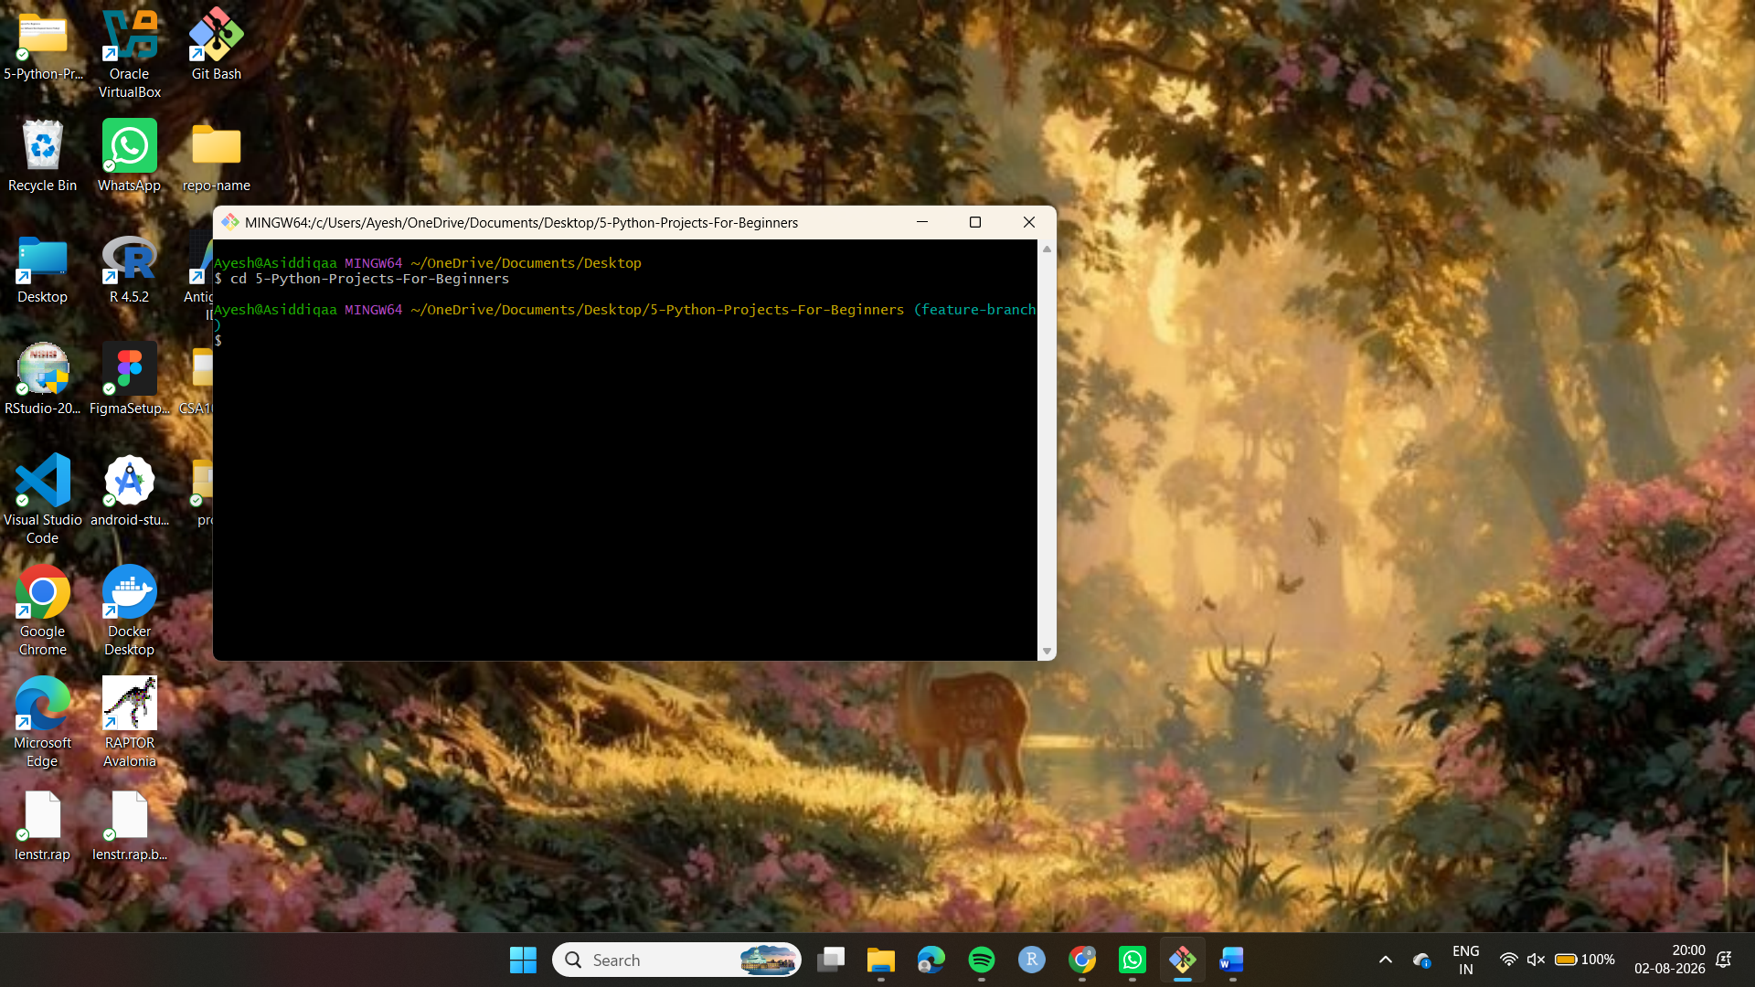
Step 2: Create a New Branch
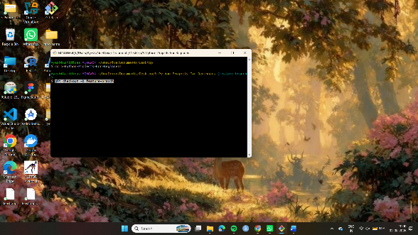

Step 2: Create a New Branch
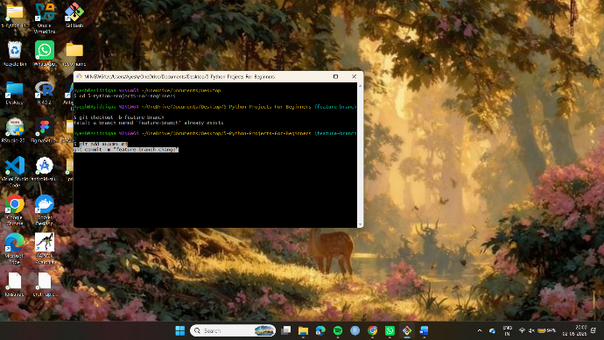
Step 3: Navigate into the project folder:
cd 5-Python-Projects-For-Beginners
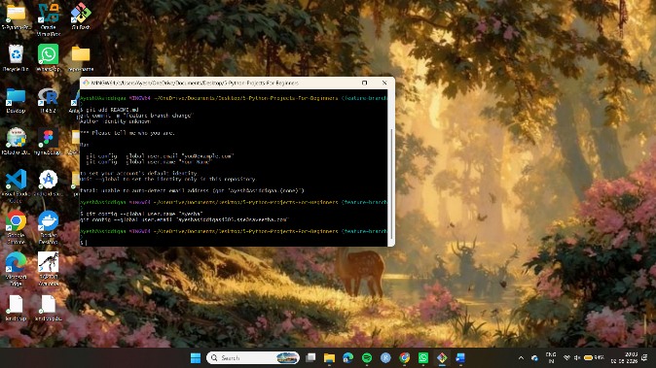
Step 4: Create and switch to a new branch:
git checkout -b feature-branch
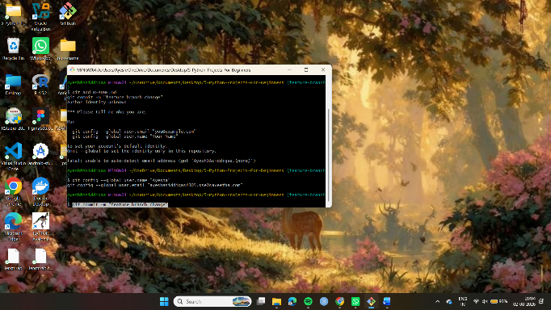
Step 5: Open the README.md file and make necessary changes.
Step 6: Add the modified file to staging:
git add README.md
Step 7: Commit the changes:
git commit -m "Updated README file"
Step 8: Push the branch to GitHub:
git push origin feature-branch
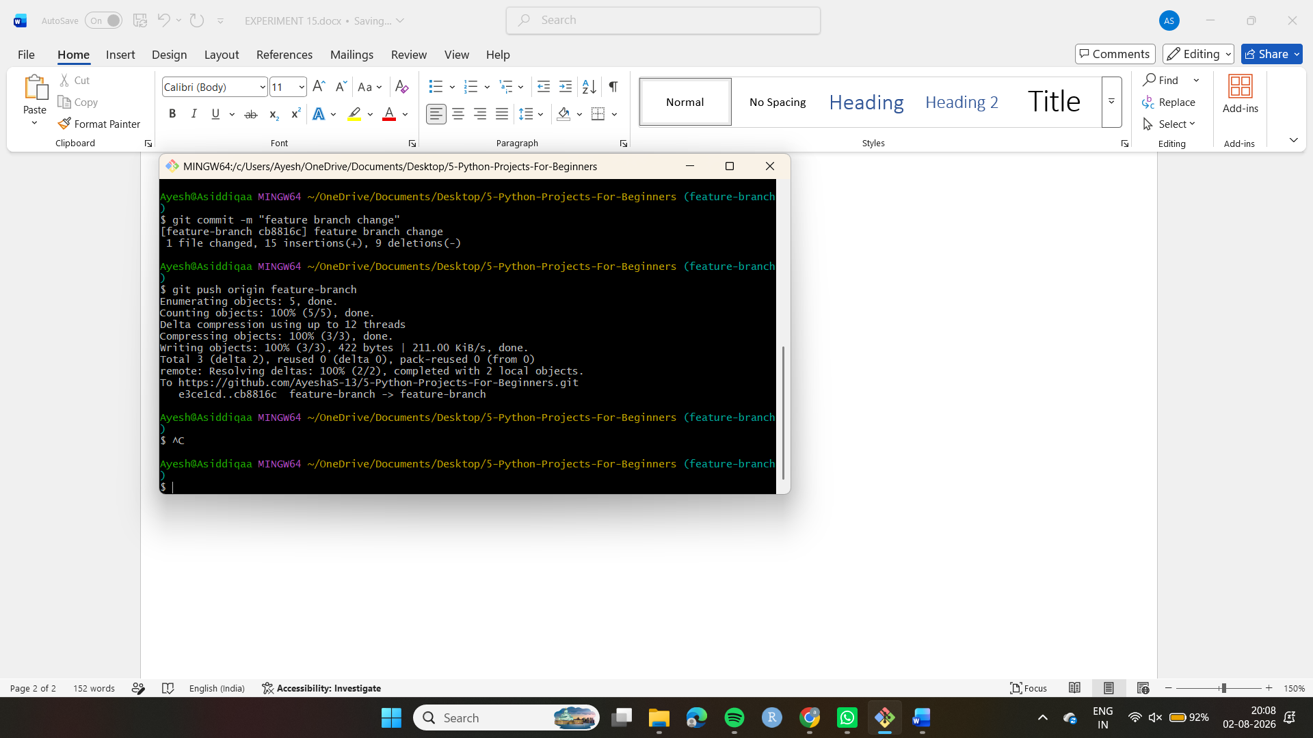
Step 9: Switch to the main branch:
git checkout main
Step 10: Pull the latest changes from the main branch:
git pull origin main
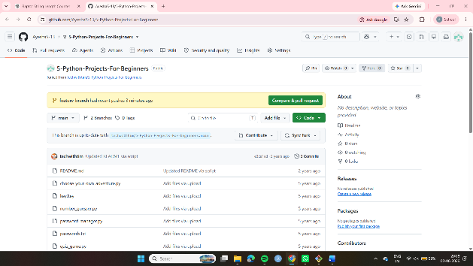
Step 11: Switch back to the feature branch:
git checkout feature-branch
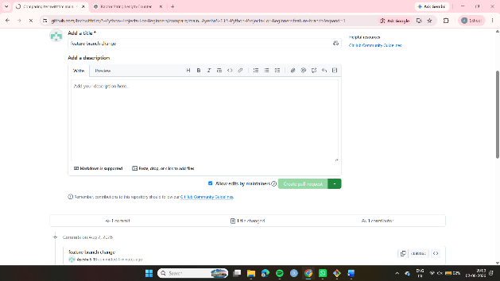
Step 12: Merge the main branch into feature branch:
git merge main

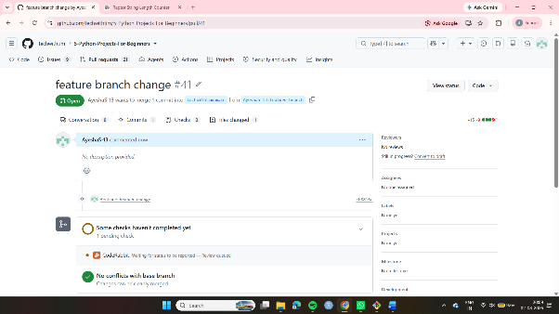
Step 16: Push the updated feature branch:
git push origin feature-branch

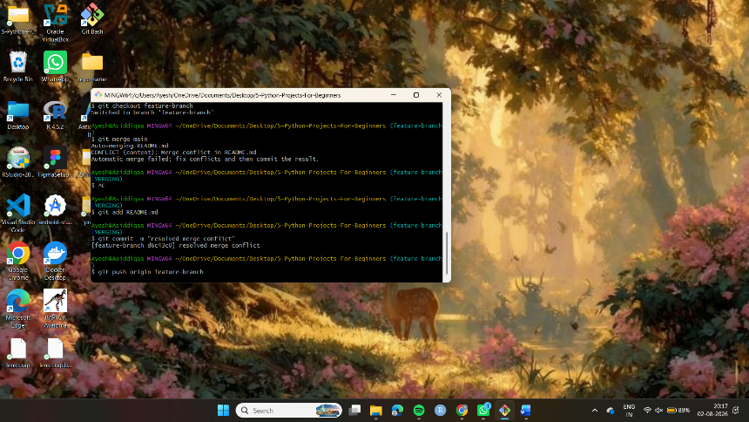
Result
